STARSTUDIO
Music Streaming Platform
Child Artist Agreement Form
Office: Shikohabad Road  Etah – 207001  Uttar Pradesh, India  Email: support@starstudio.co.in | 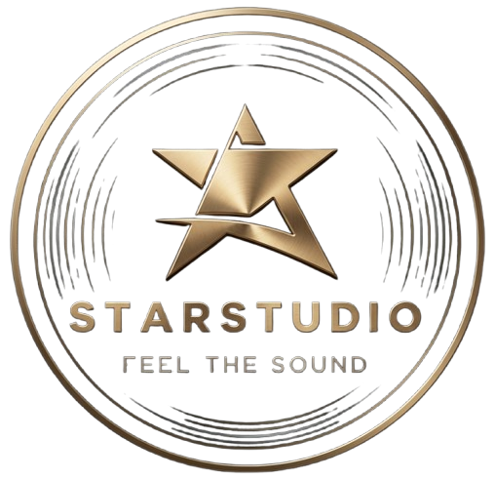

This agreement is for participation of a minor (child artist) in STARSTUDIO, a music streaming platform and digital content production service.
1. CHILD DETAILS
Full Name: ____________________________
Date of Birth: ____________________________
Age: __________
Gender: ____________________________
2. PARENT / GUARDIAN DETAILS
Full Name: ____________________________
Relation with Child: ____________________________
Address: ____________________________________________
Phone Number: ____________________________
Email ID: ____________________________
3. CONSENT & PERMISSION
I, the undersigned parent/guardian, hereby give full consent for my child to participate as an artist in audio, video, music, and digital content created under STARSTUDIO.
I understand that the content may be published on music streaming platforms, websites, and social media.

4. PAYMENT & RIGHTS
Any earnings related to the child artist will be managed by the parent/guardian. STARSTUDIO reserves rights to use, edit, publish, and distribute the content.
5. COPYRIGHT & CONTENT OWNERSHIP
- All audio, video, music, and digital content created under STARSTUDIO shall be the exclusive property of STARSTUDIO.
- STARSTUDIO shall have full rights to publish, distribute, monetize, modify, and promote the content worldwide.
- This agreement grants STARSTUDIO perpetual, worldwide, and irrevocable rights over the content.
- The child artist or parent/guardian shall not claim ownership over the final produced content.
- The artist may be credited where applicable, but ownership remains with STARSTUDIO.
6. LIABILITY DECLARATION
- The parent/guardian confirms that the child is participating voluntarily.
- STARSTUDIO shall not be held liable for any indirect claims arising from participation.

7. SAFETY & WELL-BEING
The child’s education, safety, and well-being will be prioritized at all times.

LEGAL DECLARATION
This agreement complies with applicable Indian laws regarding child participation in digital media and entertainment. Parent/guardian takes full responsibility for the minor.

Name: ____________________________ Parent/Guardian Signature
Date: ____________________________
Place: ____________________________

